# Providing AWG in buildings:

* The main problem is the lack of clean and accessible water in the proposed community. To deal with this problem the proposed building will house a number of atmospheric water generators in its upper floors (fig. 2). **Height is of importance because it gives the building access to humidity above the existing housing developments around its location.** The water produced by the generators will then be filtered and stored in water tanks around the building above the ground floor. This will allow us to use gravity as a means of moving water down for public consumption. As the building will be storing water.
* As you approach the building, you see people gathered around its structural system. The columns house the water faucets that are access free and functioning 24 hours a day. Under the faucets, a screen takes all wasted water through a filtering process and back into the storage tanks. People in line, wait for their turn to have access to the waterspout where they fill containers to take back home. The ground floor of the structure is a space of social interaction, where people gather to talk and shop, because that level functions as a market that sells the produce grown in the tower. The employees of the market are also managers for the facility and assist the public with water access. The market has a stair that links all levels of the facility. This stair takes you from the public to the private section of the building. In the first floor, we find water tanks in the center of an open plan surrounded by hanging hydroponic systems containing hundreds of plants.

# Humidity and Water Generating Technology:

* There are 3.1 quadrillion gallons of water in the atmosphere at any given time. While the average humidity in your home or office is 50%, an atmospheric water generator can produce water from humidity as low as 35%.
* “Insert information about the humidity in Africa “This makes it the perfect venue for the use of atmospheric water generators.
* //Different use of AWG using Fog or Dew:
* In the time of the Incas in Peru, most of the constructions were done high in the mountain above the rain line. So must of the water accumulation was attained by collecting dew, which was kept in cisterns and moved around the urban centers through aqueducts at ground level by using gravity.
* A modern version of the Inca passives system (named ‘Fog catcher’), is used presently in the Atacama Desert to catch fog in large nets that through capillarity and gravity collect the water on pipes at the bottom of the net and then transport the water down slope to the farming fields in the valley below the net line.
* //AWG used in our Project :
* For this project, we are using a different system based on the same method in which a compressor circulates refrigerant through a condenser and then an evaporator coil which cools the air surrounding it. This lowers the air temperature to its dew point, causing water to condense. The resulting water is then passed into a holding tank with purification and filtration system to help keep the water pure and reduce the risk posed by viruses and bacteria. The advantage of this system is that the more humidity in the air the more effective the system is.

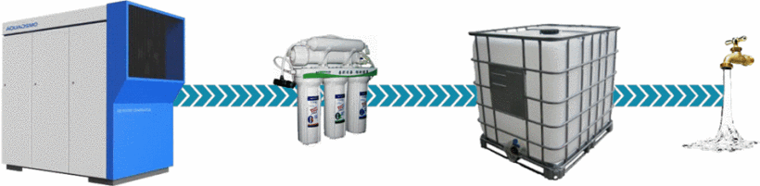

# Cost:

* The question of cost has been a very important concern on the development of this project. On one hand, the ‘urban acupuncture’ approach will always be cheaper than providing infrastructure to a large community that presently does not have it. However, the present situation is one in which the governments are not prepared to make large investments into solving these problems. We have designed multiple versions of the system at multiple price ranges depending on the materials and construction means accessible to the different populations of the proposed sites. The overall technology is not inexpensive; each atmospheric water generator is about $5000.00 dollars plus maintenance costs. But the cost can be offset by donations from companies that would want to be associated with the project, UN loans or other diverse financial options to be studied in relation to the diverse potential of each site. Ultimately, the purpose of an ‘urban acupuncture’ approach is to adapt to the potential of the community.